COMPASS TRAVEL LLC
Home of the Northern Illinois Travel Society
presents Insight Vacations LUXURY GOLD
Elegance of Egypt
November 10-18, 2020

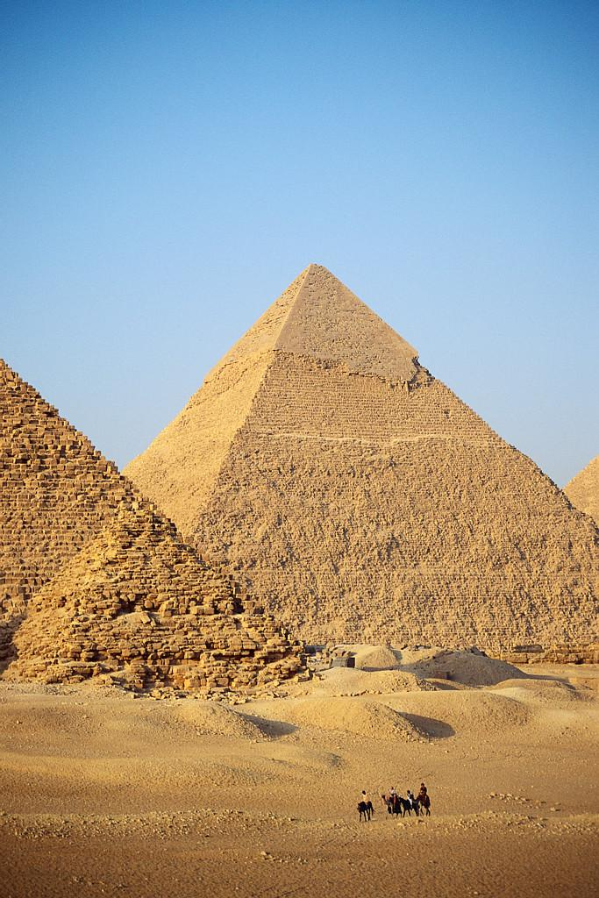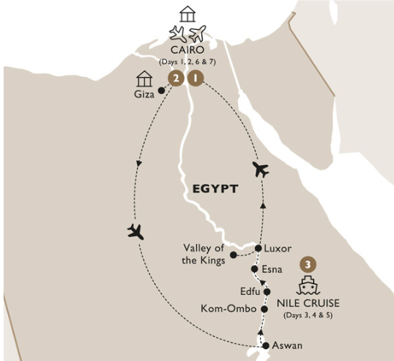

Lovers of myth and mystery will be enchanted by the sites encountered on this journey. Many of Egypt’s cities and towns developed along the Nile, so a luxurious cruise on-board the River Tosca is like a window to the heart and soul of this amazing country.

JOURNEY HIGHLIGHTS
Giza: Meet the enigmatic Sphinx and venture deep inside one of the pyramids.
Cairo: During your visit to the Egyptian Museum, gaze upon the gold coffin of Tutankhamun.
Giza: See the audio visual Sound & Light Show at the Great Pyramids.
Aswan: Witness one of Queen Hatshepsut's unfinished obelisk. Like Winston Churchill and Agatha Christie before you, enjoy the sunset and afternoon tea in colonial English-style at Aswan's famous Old Cataract Hotel.
Kitchener's Island: On a traditional Nile felucca, cruise around Kitchener's Island.
Esna: Visit Esna Temple, dedicated to the god of creation, the ram-headed Khnum, as well as Esna Lock.
Luxor: Visit the UNESCO World Heritage site of the temple of Luxor and marvel at this ancient monument.
Visit a family home and witness the making authentic Egyptian sun bread.
West Bank: See the mighty Colossi of Memnon, guarded by two giant seated figures of Amenhotep III.
Valley of the Kings: See the royal tombs and visit the Temple of Hatshepsut.
Karnak: Stand amid a vast forest of columns in the largest temple complex known to man.

EXCEPTIONAL DINING
Dining Summary: 6 Breakfasts (B), 1 Afternoon Tea (AT), 3 Lunches (L), 3 Dinners (D) all with bottled water, tea or coffee.

LUXURY HOTELS
Cairo: As far as hotels go, there are few that compare to the five-star Mena House Hotel. Having welcomed numerous heads of state over the years.
Wake up to stunning views of the pyramids from the balcony of your decadent room.
Luxury Cruising: For the ultimate in luxury and refinement, set sail on the deluxe, all-suite River Tosca. Experience old world elegance, blended with modern amenities and comfort. The spacious suites are tastefully designed with marble bathrooms.
Cairo: Perfectly located on the western bank of the Nile, the Four Seasons at the First Residence puts you at the heart if it all.
Enjoy elegance in both service and style, with rooms featuring stylish colonial décor and a rooftop pool offering stunning city views.

Price Includes:
Transfer from DeKalb to Chicago airport.
4-day cruise on UNIWORLD’S RIVER TOSCA.
All meals on board included.
All air taxes and government fees, all port charges.

Rates starting at only $5550.31 per person.

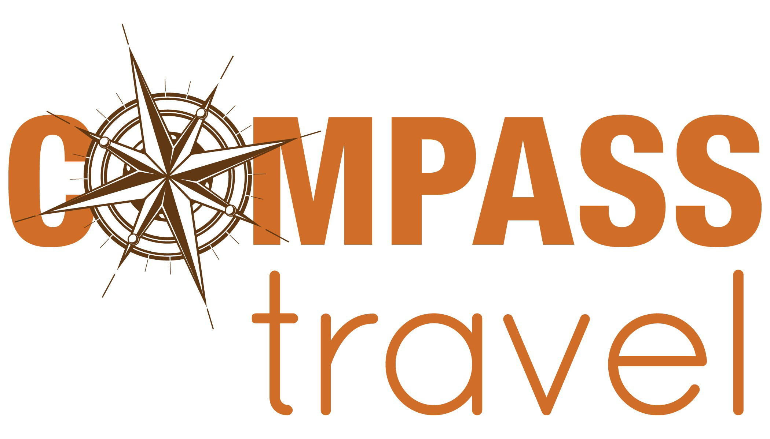

COMPASS TRAVEL LLC
home of the Northern Illinois Travel Society℠
2410 Sycamore Road, De Kalb, Illinois 60115, phone: 815-756-1547; email: info@travelwithcompass.com

Your ITINERARY

Tuesday, November 10, 2020: DeKalb to O’Hare for flight to Cairo.

Wednesday, November 11, 2020: Cairo at leisure.
Your complimentary, private transfer takes you to your local departure airport. Welcome to the timeless land of the pharaohs. On arrival in Cairo, you will be met and transferred to your hotel. Enjoy the evening at leisure as tomorrow you begin your journey into the ancient world. In the evening, get to know your Travelling Concierge and fellow guests over a welcome drink at the hotel.
Hotel: Mena House Hotel (Pyramid View), Cairo.

Thursday, November 12, 2020: Cairo sightseeing.
In the morning, meet your Travelling Concierge, a knowledgeable Egyptologist, and begin your discovery of this timeless land. Start a visit to the magnificent Pyramids of Giza, where you venture inside and visit the enigmatic Sphinx. Afterwards, visit the Egyptian Museum, to witness the priceless treasures recovered from the Tomb of Tutankhamun. Later, drive to the Pyramids to witness the magical Sound & Light Show, an unforgettable introduction to the world of ancient Egypt.
Hotel: Mena House Hotel (Pyramid View), Cairo. Meals: Breakfast

Friday, November 13, 2020: Fly to Aswan to join your cruise.
Board your plane for a morning flight across the desert to Aswan. Visit the Aswan High Dam and the granite quarries, where one of Queen Hatshepsut's obelisks lies abandoned in the bedrock. Then cross the Nile by motorboat to the well-preserved Philae temple complex, moved stone-by-stone to its current location following the construction of the High Dam. Next, stretch out on a traditional Nile felucca for a peaceful ride around Kitchener’s Island. In the late afternoon, join the likes of Winston Churchill and Agatha Christie before you, with a colonial-style high tea on the terrace of the Old Cataract Hotel. Once on your stylish and spacious cruiser, enjoy a Highlight Dinner accompanied by a Nubian folklore show and live music.
Hotel: River Tosca. Meals: Breakfast, Lunch, Afternoon Tea, Dinner with Wine

Saturday, November 14, 2020: Relaxed Start / Kom Ombo to Edfu.
The morning is at leisure to relax or explore. At lunchtime, set sail for the temple at Kom Ombo – a glorious sight as you approach by river. Unique in Egypt, it's dedicated to both the falcon-headed Horus and the crocodile god, Sobek. Then, drift past irrigated fields and palm-fringed villages to dock at Edfu. As evening falls, don your galabeyas, which are traditional Egyptian attire, for a fun-filled Egyptian dinner and galabeya party. Hotel: River Tosca. Meals: Breakfast, Lunch, Dinner with Wine

Saturday, November 14, 2020: Esna Temple and the Temple of Luxor.
Start with a visit to Esna Temple. Situated in the centre of Esna, this fascinating and highly decorated temple is dedicated to the ram-headed god Khnum, the god of creation. Then visit Esna Lock before sitting back and observing everyday life in rural Egypt as you float downstream to Luxor. Visit the Temple of Luxor as the sun sets. Hotel: River Tosca. Meals: Breakfast, Lunch, Dinner with Wine

Sunday, November 15, 2020: Luxor sightseeing and Cairo.
Across the Nile, to the west of the city, lies the necropolis of ancient Thebes. Stop for a photo of the Colossi of Memnon; these two giant seated figures of Amenhotep III once guarded his mortuary temple. In the nearby Valley of the Kings, the Egyptian kings planned to meet their gods in the afterlife. Visit some of their tombs, then continue to the temple of Queen Hatshepsut, one of the rare female pharaohs. Next, visit a family home and witness the making of authentic Egyptian sun bread. Return to Luxor for your final highlight, Karnak, the largest temple complex built by man. Walk through the avenue of ram-headed sphinxes, past the statue of Rameses II, to the vast Hypostyle Hall, housing 134 giant decorated columns. Afterwards, transfer to the airport for your flight back to Cairo. Hotel: Four Seasons at the First Residence, Cairo. Meals: Breakfast

Monday, November 16, 2020: Depart Cairo.
Your journey concludes after breakfast and you will be transferred to Cairo Airport to board your onward flight. On arrival at your home airport, your driver will greet and escort you to your waiting car for your private transfer home. Meals: Breakfast

COMPASS TRAVEL LLC
home of the Northern Illinois Travel Society℠
2410 Sycamore Road, De Kalb, Illinois 60115, phone: 815-756-1547; email: info@travelwithcompass.com

COMPASS TRAVEL LLC
Home of the Northern Illinois Travel Society

Egyptian Elegance, November 10-18, 2020
Please write your name as it appears on your passport.

Name____________________________________________________________________
Name____________________________________________________________________
Address___________________________________________________________________
City/State/Zip______________________________________________________________
Home telephone___________________________ Cell Phone_________________________
Email____________________________________________________________________

Emergency contact name _______________________________________________________
Emergency contact phone number _________________________________________________

I will be sharing a room with ___________________________________________________
[ ] If a roommate cannot be found, I agree to pay the single supplement.

[ ] Cairo Deck, $5550.31 per person/double occupancy; $6580.31 single occupancy.
[ ] Pharaoh Deck, $5725.31 per person/double occupancy; $6835.31 single occupancy.

Do you have special diet requirements? _____________________________________________
Do you have special medical requirements? _ _________________________________________

Payment Information
[ ] Enclosed is a check (payable to COMPASS TRAVEL LLC) in the amount of $1955.31 per person (made payable to COMPASS TRAVEL) per person. Balance may be made by check or credit card.

COMPASS TRAVEL encourages purchase of Travelex 360 Group Premier Travel Protection Plan for $397/$472.

____ I wish to purchase the Group Premier Travel Protection Plan (this provides trip cancellation in addition to many other insurance benefits and non-insurance services).
____ I do not wish to purchase the Group Premier Travel Protection Plan.

I have read the terms and conditions. Signature______________________________

TERMS AND CONDITIONS
The tour price is based on a minimum participation of 20 passengers and includes planning, handling, and operational charges and is quoted on the current rate of exchange, tariff rates and airfares. Should these costs change, a surcharge may be made on the price of your vacation. Port charges, taxes, fuel surcharges, and any fees imposed by the government or it agencies are subject to change. Cancellation fees will apply per Holland America Line’s brochure. Any physical disability requiring special attention or treatment must be reported in writing when reservations are made. COMPASS Travel LLC, and Sponsoring Organizations/tour leaders or any individual act in behalf of the promotion of this tour, act only as agents for the passenger in regard to travel, whether by railroad, motor car, motor coach, ships, or airplane. Arrangements for all features described and the pricing of it are the result of agreement between COMPASS Travel LLC. and Service Providers, which form the agreement between COMPASS Travel LLC. and Sponsoring Organizations. By issuance of ticket or coupons, Sponsoring Organizations and COMPASS Travel LLC. shall not be liable for any injury, damage, loss, accident, delay or irregularity which may be occasioned by reason of defect in any vehicle or failure to carry out such arrangements as mentioned; nor for the misconduct of such parties. Sponsoring Organizations/COMPASS Travel LLC. reserves the right to withdraw or make any changes or alterations as may be found necessary for the proper handling of said tour.

Please attach copy of photo page of your passport or passport card.
A passport or passport card valid for six months beyond return date is required.

COMPASS TRAVEL LLC
home of the Northern Illinois Travel Society℠
2410 Sycamore Road, De Kalb, Illinois 60115, phone: 815-756-1547; email: info@travelwithcompass.com

